Funeral Planning Guide

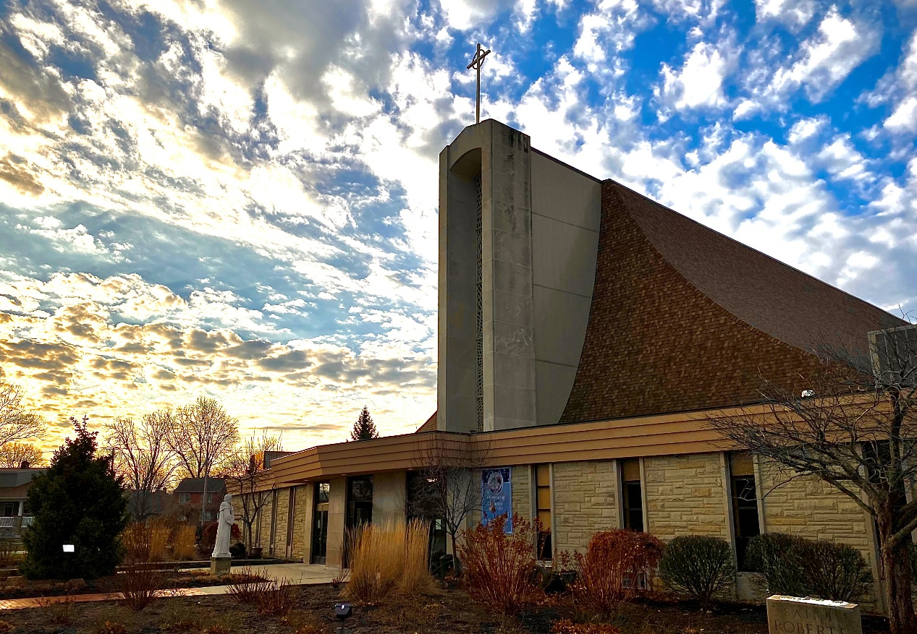

Ss. Robert and William Catholic Parish

367 East 260th Street, Euclid, Ohio 44132 Phone: 216.731.1515

www.srweuclid.cc

Fr. Michael Stalla Fr. Thomas Kowatch

Pastor, Ext. 228 Parochial Vicar, Ext. 229 mstalla@srweuclid.cc frkowatch@srweuclid.cc

Alex Ulle, Music Director, Ext. 241 Anita Linsky, Office Manager, Ext. 221

aulle@srweuclid.cc alinsky@srweuclid.cc

The staff of Ss. Robert and William Parish has prepared these guidelines to assist your family in planning your loved one’s Funeral Mass. We hope that by choosing the readings and music, you and your family might share more fully in the liturgy and express your care and love for the deceased. Attached to this booklet is a liturgy planning form to plan the Funeral Liturgy. Please fill it out to the best of your ability and bring it with you to your meeting with the priest or pastoral associate. Be assured of the prayers of our parish during this time of sorrow.

General Information

Catholic Funeral
The Church confidently proclaims that Jesus, the Son of God, by his death and resurrection, has broken the chains of sin and death. The Order of Christian Funerals celebrates this in three groups of rites that correspond to the three ritual movements in the funeral of Christians. These three movements form one procession beginning with the Vigil (wake), followed by the Funeral Mass, and ending with the Rite of Committal at the cemetery. While this is the usual custom, options are available.

Cremation
In recent years, the restriction of cremation has been lifted. While the Church encourages cremation to follow the Funeral Liturgy, it realizes that financial constraints or other circumstances may result in the desire for cremation before the funeral services. Cremated remains are brought to the church and treated the same as if a body were present. The Church discourages the dividing or scattering of ashes. It is proper to bury the cremains.

Scheduling a Funeral
According to diocesan guidelines, funeral Masses can be held any day of the year with the exceptions of Sundays, Holy Days, or during the Sacred Triduum (Holy Thursday, Good Friday, Holy Saturday).

Funeral Home
It is most common and convenient for a family to use the services of a funeral home to coordinate the various events of the funeral. The parish works well with area funeral homes and will work together with their staff to ensure a seamless funeral. If you choose not to use a Funeral Home, please see the note under “Stipends.”

Wake/Visitation Prior to the Mass
It is becoming more common for families to request use of the church for an hour or two prior to the Mass for visitation in lieu of a traditional wake/visitation at a funeral home. While we do not encourage this, we are very open to it and happy to accommodate. If you choose to use the church, please see the note under “Stipends.”

Mass Worship Booklets
Our parish is happy to provide the worship booklets for the funeral. It is very important that the information be given to us as soon as possible to allow time for creating and printing. If you would like a picture of your loved one included on the front of the booklet, email his/her picture to alinsky@srweuclid.cc or bring a picture with you when you come to the planning meeting and we will scan it for you. Please estimate the number of booklets that will be needed.

Ministers
Readers: We will provide readers from the parish to proclaim the readings and Universal Prayer. However, family or friends who want to participate in these liturgical roles may do so. Readers should be Catholics familiar with the Mass and should have a good public speaking voice. We will provide you with copies of your chosen readings when you meet with the parish staff.
Gift Bearers: You may choose two or more people to bring the bread and wine forward during the Offertory.
Musicians and Servers: Our staff will contact our parish musicians and servers. Please note music selections must be approved as sacred music. If you choose to have other singers or musicians, please speak with the staff member with whom you are working with. An additional stipend may be appropriate.

Remarks of Remembrance (Eulogy) Guidelines
If a eulogy is given, it is most appropriately given at the funeral home or cemetery. However, under exceptional circumstances when this is not possible, diocesan guidelines permit one person to offer a short eulogy at the beginning of Mass before the Opening Prayer. A good eulogy should only be 2-3 minutes (which amounts to one page, single-spaced, 12-point font). Please note that a eulogy is not a biography of the deceased, nor a long telling of many events and stories about the deceased. Rather, the eulogist shares one story to help those gathered remember the faith, hope, and love of the deceased. The eulogist should have some public speaking skills. He or she should keep all remarks appropriate for a Catholic Mass. Please give the priest celebrant a copy of the eulogy for feedback prior to the funeral.

Stipends
It is customary to pay the parish a stipend of $400 to cover the cost of the church, worship aids, priest, and music. Generally, the funeral home will include this $400 in their charge to a family and then pay the parish directly. If you would like to pay this stipend directly to the parish, please let the funeral home know that you plan to do this. Also, please plan on paying the stipend directly to the parish if you are not working with a funeral home.
If there are any issues with finances, please inform the staff member with whom you are working with, and he/she will assist you.
- If you choose to use the church for the wake/visitation, there is a $100 fee for this to cover our costs.

Mass Offerings
Masses for the intention of the deceased can be requested through Ss. Robert and William or any parish church. The usual stipend is $10.00 per Mass. Due to a large volume of requests, we can only schedule two Masses per year for each household based on availability. Additional intentions may be distributed to other parishes, to the missions, or to retired priests. Mass intentions can only be accepted for dates within a year of the request.

Other Donations
If you wish to honor your loved one by donating to a special fund or ministry, our staff can assist you in that decision. We discourage individual purchases of memorial vessels and vestments since this often results in an overabundance of items for the parish.

Universal Prayer (Prayer of the Faithful)

Please review the format of the Universal Prayer below. Let the priest know of any relatives, living or deceased, that you would like to add to these intentions:

For N. who in baptism was given the pledge of eternal life, may he/she now be admitted to the company of the saints. We pray to the Lord.

For N. who ate the body of Christ, the bread of life, may he/she be seated at the heavenly banquet table.
We pray to the Lord.

For ourselves, may the Lord grant us the gift of His loving compassion as we grieve. We pray to the Lord.

For our deceased relatives and friends, especially N., may they rest from their labors and be embraced by God forever. We pray to the Lord.

For all of us assembled here to worship in faith, may we be gathered together with N in God’s Kingdom. We pray to the Lord.

Readings for the Liturgy of the Word

FIRST READING The first reading is taken from the Old Testament, or during the Easter season, from the Acts of the Apostles or Revelation. Please choose one of the following readings and mark your selection on the planning form. A short passage containing the main message has been provided.

1000 Proverbs 31:10-30
“When one finds a worthy wife, her value is far beyond pearls”

1005 Ecclesiastes 3:1-8, 14
“There is an appointed time for everything, and a time for every affair under the heavens.
A time to give birth and a time to die; a time to plant and a time to uproot the plant.”

1010 Wisdom 3:1-6, 9
“The souls of the just are in the hands of God, and no torment shall touch them…”

1015 Wisdom 4:7-15
“The righteous one, though he die early, shall be at rest.
For the age that is honorable comes not with the passing of time,
nor can it be measured in terms of years.”

1020 Sirach 3:2-5, 12-15
“The Lord sets a father in honor over his children…
My son, be steadfast in honoring your father; do not grieve him as long as he lives.”

1025 Sirach 51:1-2, 9-12
“I declare your name, refuge of my life, because you have ransomed my life from death.”

1030 Isaiah 25:6a, 7-9
“The Lord God will wipe away the tears from all faces…
Behold our God, to whom we looked to save us!”

1035 Isaiah 40:28-29, 31
“They that hope in the Lord will renew their strength,
they will soar on eagles’ wings; they will run and not grow weary…”

1040 Lamentations 3:22-26
“The favors of the Lord are not exhausted. his mercies are not spent;
They are renewed each morning – so great is his faithfulness.”

1045 [Easter Season Only] Acts 10:34-36, 42-43
“To him all the prophets bear witness, that everyone who believes in him
will receive forgiveness of sins through his name.”

1050 [Easter Season Only] Revelation 14:13
“Blessed are the dead who die in the Lord from now on.
Let them find rest from their labors, for their works accompany them.”

1055 [Easter Season Only] Revelation 21:1-5a, 6b-7
“I saw the holy city, a new Jerusalem, coming down out of heaven from God.
I am the Alpha and the Omega, the beginning and the end.”
SECOND READING The second reading is always taken from the New Testament. Please choose one of the following and indicate your selection on the planning form. A short passage containing the main message has been provided.

2000 Romans 6:3-4, 8-9
“Are you unaware that we who were baptized into Christ Jesus were baptized into his death?
As Christ was raised from the dead by the glory of the Father, we too might live in newness of life.”

2005 Romans 8:14-23
“You received a spirit of adoption, through which we say Abba ‘Father!’
We are children of God, and if children, then heirs.”

2010 Romans 8:31b-35, 37-39
“If God is for us, who can be against us? ...What will separate us from the love of Christ?”

2015 Romans 14:7-9; 15:13
“No one lives for oneself and no one dies for oneself.
For if we live, we live for the Lord, and if we die, we are the Lord’s;
so then, whether we live or die, we are the Lord’s.”

2020 1 Corinthians 2:7-10
“…eye has not seen, and ear has not heard, and what has not entered
the human heart, what God has prepared for those who love him.”

2025 1 Corinthians 15:51-57
“We shall not all fall asleep, but we will be changed, in an instant, in the blink of an eye…”

2030 2 Corinthians 4:14-18, 5:1
“We know that the One who raised the Lord Jesus will raise us also with Jesus.
For this momentary light affliction is producing for us an eternal weight of glory
beyond all comparison, as we look not to what is seen but to what is unseen…”

2035 2 Corinthians 5:1, 6-9
“We know that if our earthly dwelling, a tent, should be destroyed,
We have a building from God, a dwelling not made with hands, eternal in heaven.”

2040 Philippians 3:20-21 “Our citizenship is in heaven.”

2045 Philippians 4:4-9
“Have no anxiety at all, but in everything…make your requests known to God.
Then the peace of God that surpasses all understanding will guard your hearts and minds in Christ Jesus.”

2050 1 Thessalonians 4:13-18
“We do not want you to be unaware, brothers and sisters, about those who have fallen asleep,
so that you may not grieve like the rest who have no hope.”

2055 Timothy 4:6-8 “I have competed well; I have finished the race; I have kept the faith.”

2060 1 Peter 1:3-4, 6, 8-9
“Blessed be the God and Father of our Lord Jesus Christ, who in his great mercy gave us a new birth”

2060 1 John 3:1-2
“See what love the Father has bestowed on us that we may be called children of God.”
GOSPEL
The Gospel is always proclaimed by the priest or deacon. Please choose one of the following Gospel readings and mark your selection on the planning form.

3000 Matthew 5:1-12a
“Blessed are the poor in spirit for theirs is the kingdom of heaven… Blessed are they who mourn, for they will be comforted.”

3005 Matthew 11:25-30
“Come to me, all you who labor and are burdened, and I will give you rest.”

3010 Matthew 25:31-46
“…whatever you did for one of these least brothers of mine, you did for me.”

3015 Matthew 28:1-10
“Do not be afraid! I know that you are seeking Jesus the crucified. He is not here, for he
has been raised, just as he said.”

3020 Luke 23:33, 39-43
“Jesus, remember me when you come into your kingdom…”
“…Amen I say to you, today you will be with me in Paradise.”

3025 Luke 24:13-16, 28-35
“Was it not necessary that the Messiah should suffer these things and enter into his glory…
“Stay with us, Lord, for evening draws near…” “Were not our hearts burning within?”

3030 John 6:37-40
“For this is the will of my Father, that everyone who sees the Son and believes in him
may have eternal life, and I shall raise them on the last day.”

3035 John 11:17-27
“I have come to believe that you are the Messiah, the Son of God…”

3040 John 12:23-26
“unless a grain of wheat falls to the ground and dies, it remains just a grain of wheat;
but if it dies, it produces much fruit.”

3045 John 14:1-6
“Do not let your hearts be troubled. You have faith in God; have faith also in me.
In my Father’s house there are many dwelling places.

3050 John 20:19-29
“Blessed are those who have not seen and have believed.”

Music Selections

RESPONSORIAL PSALM
The musician and cantor lead the assembly in singing the response. Please choose one of the following Psalm responses and mark your selection on the planning form.

Psalm 23 “The Lord is my shepherd, there is nothing I shall want.”

Psalm 25 “To you, O Lord, I lift my soul.”

Psalm 27 “The Lord is my light and my salvation.”

Psalm 42 “As the deer longs for running streams, so I long for you.”

Psalm 103 “The Lord is kind and merciful.”

Psalm 116 “I will walk in the presence of the Lord in the land of the living.”

HYMNS
Please choose a hymn under each heading. A reflection Hymn is optional after Holy Communion. The hymns listed under each heading are suggestions; they may be moved elsewhere. Numbers correspond to Journey Songs hymnal used by our parish. Only sacred (religious) music may be used at the Funeral Mass. It is never appropriate to use secular music.

Opening Hymns
All Creatures of Our God and King 578
Be Not Afraid 673
Here I Am, Lord 818
Hosea 529
I Heard the Voice of Jesus Say 692
I Know That My Redeemer Lives 129
Joyful, Joyful We Adore You 575
Lord of All Hopefulness 647
On Eagle’s Wings 671
There’s A Wideness in God’s Mercy 712
Sing to the Mountains 580

Offertory Hymns
Ave Maria
Be Still My Soul 547
Be Thou My Vision 646
Come to the Water 626
Hail Mary, Gentle Woman 481
How Great Thou Art 614
In Every Age 696
Open My Eyes, Lord 659
Precious Lord, Take My Hand 548
Prayer of St. Francis 702
Remember Your Love 533
The King of Love (Irish) 690
The Servant Song 816
You Are Near 687

Communion Hymns
Behold the Lamb 785
Center of My Life 665
Gift of Finest Wheat 791
Eye Has Not Seen
I Am the Bread of Life
I Received the Living God 786
Jesus, Remember Me
One Bread, One Body 793
Panis Angelicus
Taste and See
The Supper of the Lord 774
Worthy is the Lamb 754
Unless a Grain of Wheat 725

Closing Hymns
Canticle of the Sun
City of God 813
For All the Saints 504
Holy God, We Praise Thy Name 566
Jerusalem, My Happy Home 758
Let There Be Peace on Earth 703
Lead Me, Lord 733
Sing with All the Saints in Glory 759
Sing to the Mountains 580
Go In Peace 561

Funeral Mass Planning Sheet

Funeral of: Date: Time:

Presider: ○ Body or ○ Cremains (Ashes)

Booklets Needed (i.e., Guest Count): Burial Date: __________ Time: ___________

Liturgy of the Word

1st Reading: Read by:

2nd Reading: Read by:

Gospel: (Read by Priest)

Universal Prayer: : Read by:

Presentation of the Offertory Gifts (2-4 people): Names:

Hymns Choose five songs. We will put them in proper order.

What are a few things you will remember most about the character of the deceased?

___________________________________________________________________________________________

